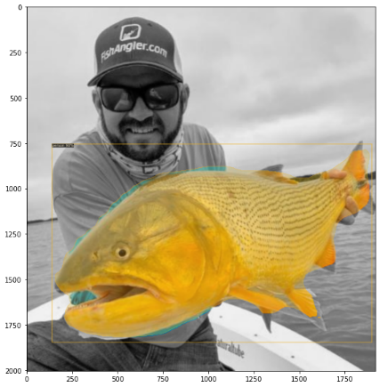
AI technology To Revolutionize the Fishing and Conservation Industries
Lighthouse Point, South Florida — The Wye Foundation is honored to launch “Fishial.AI” a nonprofit project that seeks to allow computers utilizing artificial intelligence to identify all fish species by name. The Fishial Recognition team which is made up of marine biologists, managers and engineers have initiated work on “Fishial Recognition™”, like facial recognition, isolates fish traits to identify all fish species world-wide.

Humanity has documented much of the planet, but we still have a problem with fish identification. With over 34,000 fish species, this process can be extremely tedious for humans and prone to error. There are no automated tools specifically designed to identify fish species by name…yet. “Fishial recognition will be a fundamental technology that will fuel the advancement of education, new species identification, fish tracking, and fishery management. “We are also creating an open source ML labeled fish species dataset that will also spur the creation of new AI approaches inspiring advancement in fisheries globally.” Says Thomas Wye, Founder and Project Manager at the Fishial project.

Fishial.AI has taken the first steps in creating a website with a backend machine learning platform which allows people to help on this project. By uploading your fish images to the Fishial portal, you can help in building the largest fish image database labeled for AI in existence. Fishial needs thousands of photos for each of the 34,000 species which is why they are asking people everywhere to join their cause. Your help will teach computers to “see” and identify fish species.

Participation is free, and using the tool is easy. Just upload your fish images, tag the fish species, and add the identifying attributes of the fish. Fishial is also seeking for volunteer experts in the field of AI research to assist in building and fine-tuning the fish identification AI neural network.

Do you share a passion for marine life or artificial intelligence? They are looking for passionate people willing to help. Fishial.AI will change the way the world sees fish and usher in a new era of fishery conservation. They invite you to join the cause as they strive to make this exciting technology a reality.

Go to https://www.fishial.ai to find out more about this project and how to get involved.

Name of Founder and Project Manager: Thomas Wye
Email: twye@wyefoundation.org

Name of Marketing and Outreach Manager: Dario Stawski
Email: ds@wyefoundation.org

